**[Ultimate Financial Advisor](http://localhost:5174/)** [Home](http://localhost:5174/) [About Us](http://localhost:5174/about) [Our Vision](http://localhost:5174/vision) [Our Clints](http://localhost:5174/clients) [Contact Us](http://localhost:5174/contact)

Slider Images

Why People Choose Us

We are a BPO firm dealing with many clients based in USA we are already working with a CPA firm and as a growing business looking for another collaboration for bookkeeping for your clients.

#### **Experience**

We have a team with diverse qualifications like CPA, ACCA

 Responsible for payroll Gusto, Paychex etc

Expert at designing accounting functions, systems, and best practices.

Responsible for reviewing & compiling client’s financial statements from E-commerce, Health, Automobile.

Responsible for reviewing & compiling client’s Construction, Manufacturing & entertainment industries.

Expertise in remote work with minimal supervision, ensured client information confidentiality.

Maintained positive relationships with prompt response to calls and emails

Experience using online tools like Slack, Asana, Hubstaff, One Drive, Google Drive, and Zoom.

Bookkeeping, accounting, and payroll services.

Expert in Costing, Budgeting, Forecasting, Financial Modelling, Valuations, and much more finance-related workings.

ABN registration

#### **What we can offer you**

Financial Statement Preparation and Analysis

Bookkeeping including Invoicing and Collections

Budgets and Financial Forecasting

Bank and Credit Card Reconciliation

Quickbooks Online, XERO & ZOHO Cleanup Bookkeeping

Creating CSV's, translation of Data for accurate bookkeeping (QuickBooks Online)

Landlord statements reconciliation like Appfollio, Cooper, Newrez (Shellpoint)

Reconciling Line of Credit.

Migration of Data from QB Desktop to QB Online

Our Core Team

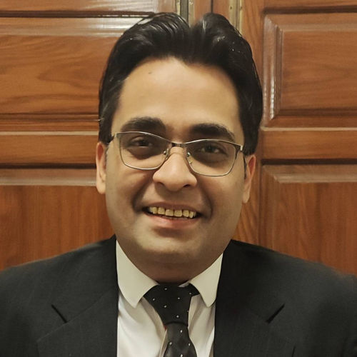

### **Syed Umair Anwar**

Fellow Member of Association of Chartered Certified Accountants

14 Years of Experience



### **Salman Ahsan**

CEO of Pak Premiere Education Consultancy



### **Faizan Mustafa**

MBA Australia, MPA Australia, Associate member of CPA Australia

10 Years of Experience

Video Section

Get Discount Info

Subscribe to the Ultimate Financial Advisor mailing list to receive updates on new arrivals, special offers and other discount information.

Top of Form

SUBSCRIBE

Bottom of Form

Footer

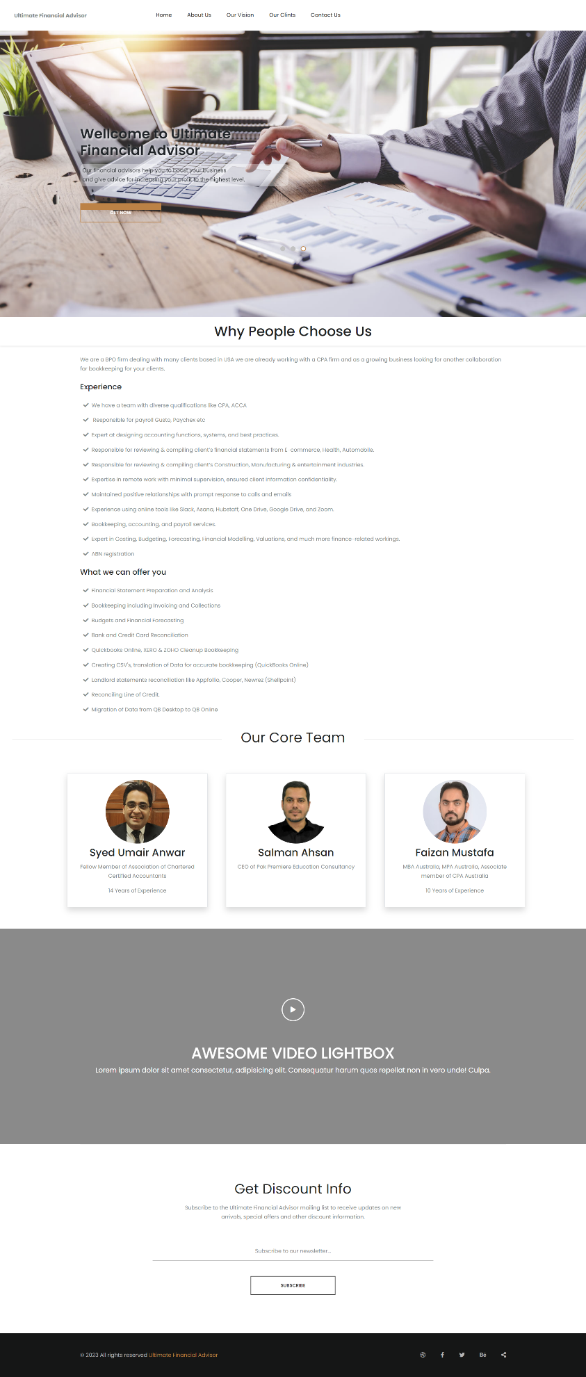

## About Us

Welcome to Ultimate Financial Advisor, your trusted partner in financial planning and wealth management. With a passion for helping individuals and businesses achieve their financial goals, we provide expert guidance and personalized solutions tailored to your unique needs.  
At Ultimate Financial Advisor, we understand that managing your finances can be complex and overwhelming. That's why our team of experienced financial advisors is here to simplify the process, offering you clarity and peace of mind. Whether you're planning for retirement, looking to grow your investments, or seeking strategies for tax optimization, we have the knowledge and expertise to guide you every step of the way.

##### **Our Approach :**

We believe that financial planning is not just about numbers; it's about understanding your aspirations, dreams, and values. By taking the time to listen and learn about your specific goals, we can develop a customized plan that aligns with your vision of a secure financial future. We combine our in-depth industry knowledge with a personalized approach, ensuring that our recommendations are tailored to your unique circumstances.

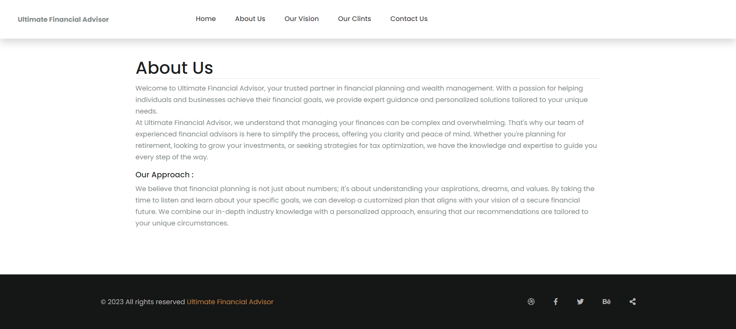

## Our Vision

At Ultimate Financial Advisor, our vision is to empower individuals and businesses to take control of their financial future and achieve lasting prosperity. We strive to be the premier financial advisory firm, recognized for our unwavering commitment to our clients' success and our innovative approach to wealth management.

###### **Our vision is built on four fundamental pillars:**

**1.**Client-Centric Focus: We place our clients at the heart of everything we do. Our vision is to create a personalized experience that exceeds expectations and delivers exceptional value. By understanding our clients' unique goals, aspirations, and challenges, we can provide tailored solutions and guidance that help them navigate the complexities of the financial world.

**2.**Trust and Integrity: We believe that trust is the foundation of every successful relationship. Our vision is to foster an environment of integrity, transparency, and accountability. We aim to build long-lasting partnerships based on trust, ensuring that our clients have confidence in our advice and recommendations. We are committed to acting in our clients' best interests at all times, putting their financial well-being above all else.

**3.**Innovation and Expertise: In an ever-changing financial landscape, our vision is to stay ahead of the curve. We strive to be at the forefront of industry trends, technological advancements, and investment strategies. Our team of highly skilled financial advisors is dedicated to continuous learning and professional development, ensuring that we provide cutting-edge solutions and expert guidance to our clients.

**4.**Empowerment and Education: We believe that knowledge is power. Our vision is to empower our clients with the knowledge and tools they need to make informed financial decisions. We are committed to educating our clients, demystifying complex concepts, and helping them develop a deeper understanding of their financial options. By equipping our clients with the necessary information, we empower them to take an active role in their financial journey.

Together, these pillars guide us in our pursuit of excellence and shape our vision for the future. We are passionate about making a positive impact in the lives of our clients, helping them achieve financial freedom, security, and a legacy of prosperity.

Join us on this journey toward financial success. Together, we can turn your dreams into reality and build a brighter future.

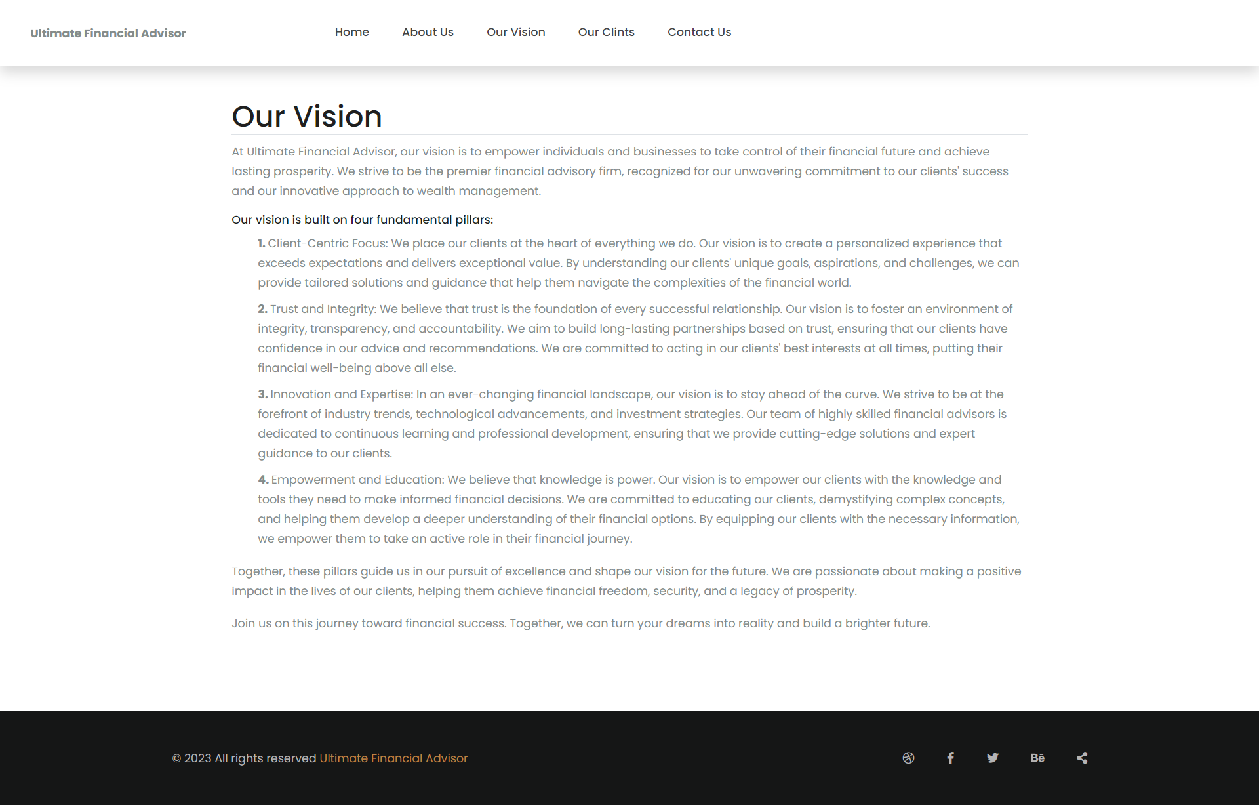

## Our Clients

#### **[Cetrix Technologies](https://cetrixstore.com/" \t "_blank)**

**Annual Turnover:**$16 million

**Industry:**Personal Protective Equipment’s

**About:**At Cetrix, we are committed to our steadfast goal of supplying certified PPE to schools, businesses, and government agencies. While the rapid manufacturing and distribution of vaccines has spurred hope that the end of this pandemic is in sight, now is not the time to let down our collective guard. Maintaining proper safety protocols, such as social distancing and wearing masks, will be essential in driving down the infection rate even further. With this in mind, Cetrix will continue to offer the highest quality masks, gloves, face shields, and other products that have been proven to slow the spread of this virus. As such is the case with many companies, the pandemic has changed our business model. We have moved from manufacturing and designing mobile computing devices and integrated mobile technologies for vertical markets, to offering high quality PPE and ramping up production of UV disinfectant cabinets.

[MORE INFO](https://cetrixstore.com/)

#### **[Vizocom](https://www.vizocom.com/" \t "_blank)**

**Annual Turnover:**$25 million

**Industry:**Personal Protective Equipment’s for US Government Departments

**About:**Vizocom has delivered many different projects and services in different locations around the world, and they all have three things in Common; Great Partnership, Hard Work, and Professionalism. Each of these may mean differently to different people, but at Vizocom, they all combine to serve our customers and the communities we work in. No matter the location; – from Sunny California to Sunny Africa, from volatile deserts in the Middle East to beautiful and serene Balkans, – we work hard, we collaborate with the stakeholders, and we treat all with professionalism. From the most complex infrastructure projects to the most sensitive design jobs, from Life Support Services to Cyber Security and AI, we are putting our commitment to collaboration to work.

[MORE INFO](https://www.vizocom.com/)

#### **[Happy Trail](http://localhost:5174/clients" \t "_blank)**

**Annual Turnover:**$8 million

**Industry:**Medicated Hemp products

**About:**

[MORE INFO](http://localhost:5174/clients)

#### **[Techfin CPA Firm](http://techfinllc.com/" \t "_blank)**

**Annual Turnover:**$

**Industry:**

**About:**TechFin is a consulting and staffing firm that specializes in automation, specifically automation of all things Finance. Our CEO is a Certified Corporate Financial Planning & Analysis Professional and a former Founder, Entrepreneur and CEO of a successful eCommerce company. We have over 30 years of career experience in IT, Finance, eCommerce, early stage companies and publicly held Fortune 100 companies. We have worked in, or consulted for, eCommerce, telecommunications, transportation, retail and various other industries.

[MORE INFO](http://techfinllc.com/)

#### **[CETDIGIT Cloud Services](https://www.cetdigit.com/" \t "_blank)**

**Annual Turnover:**$12 million

**Industry:**Cloud Digital services

**About:**Enterprises struggle to transform into digital business by failing to automate the operational processes that underpin the customers journey. A new generation of digital process automation practices, platforms, and plans are the answer. We are focused on building fully integrated Salesforce solutions that will guarantee a future-proof digital transformation designed to keep you competitive and improve profitability. We actively work with your team to revamp your processes, streamline your business and create an unmatched customer experience. Our business today has evolved into one with a core focus on building fully integrated solutions using the Salesforce platform. Our clients have come to know us as their one-stop Salesforce consulting partner, offering them a complete range of services N system strategy and optimization; user adoption; process improvement and workflow; mobile enablement and development; custom development; integration; administrator support and training; marketing automation services; and, more. Our team views and achieves a faster, smarter, and more personalized buyer journey by fostering digital transformation and maximizing the effectiveness of AI in Connected Business. This business transformation requires the best in cloud technology through a comprehensive understanding of the realities of the enterprise.

[MORE INFO](https://www.cetdigit.com/)

#### **[FURNITURE USA](https://www.furnitureusa.com/" \t "_blank)**

**Annual Turnover:**$28 Million

**Industry:**Household Furniture trading & manufacturing

**About:**Furniture USA is known for its high-quality, American made furniture with friendly and dependable customer service. We deliver comfort made in the USA right into your home. We are a family-run business that is committed to impacting the American Furniture Manufacturing industry. When you buy on our website you can feel confident that you are buying high-quality furniture, made in the USA, that will last for years to come. Our highly experienced furniture specialists are to help you find the perfect piece for your home.

[MORE INFO](https://www.furnitureusa.com/)

#### **[Florida Eagle Investment Homes](https://floridaeaglehomesales.com/" \t "_blank)**

**Annual Turnover:**$50 Million

**Industry:**Real Estate property management

**About:**At FEI Homes, our inventory goes fast due to our easy purchase programs. If you don’t find what you are looking for here, chances are we’ll have a house in inventory soon that will meet your needs. If you wish to be notified as soon as a house becomes available that meets your criteria, be sure to join our Buyers List by completing our PRELIMINARY HOME OWNERSHIP APPLICATION. Why rent when you can buy? To see the advantages of Renting vs Owning, please look at our Rent Vs. Buy calculator. Some properties may be available on our “Work For Equity Program™” where you can earn credit towards your move-in fee or down payment for agreeing to do some or all of the repairs. This is not a requirement as we can do all of the repairs if you choose not to.

[MORE INFO](https://floridaeaglehomesales.com/)

#### **[Schlabach Engine](http://localhost:5174/clients" \t "_blank)**

**Annual Turnover:**$9.5 Million

**Industry:**Hardware equipment for daily use

**About:**We are very proud to be a retailer of the STIHL product line. As an independent STIHL Dealer, we can provide many services that the big box chain stores just can’t match. We are confident that our friendly and knowledgeable staff will be at the ready to help you select the equipment that meets your specific lawncare needs. From the quality of our dedicated staff to the quality of the STIHL line of products, we have what you need to get your job done quickly and efficiently. In support of independent retail stores across the country, STIHL is a proud sponsor of Independent We Stand – a nationwide movement supporting independently owned businesses and the role they serve in local economies. You can continue to support the cause by shopping at your area’s locally owned businesses, including your neighborhood independent STIHL Dealer.

[MORE INFO](http://localhost:5174/clients)

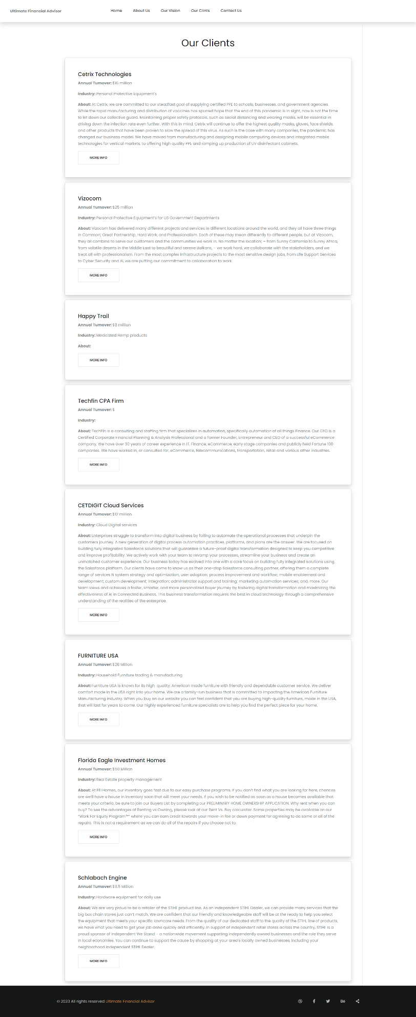

Contact Us

